Unit VI Introduction to Engineering Materials Dielectric materials
- A dielectric is an insulator that can be polarized by an applied electric field. When a dielectric material is placed in an electric field, electric charges do not flow through the material.
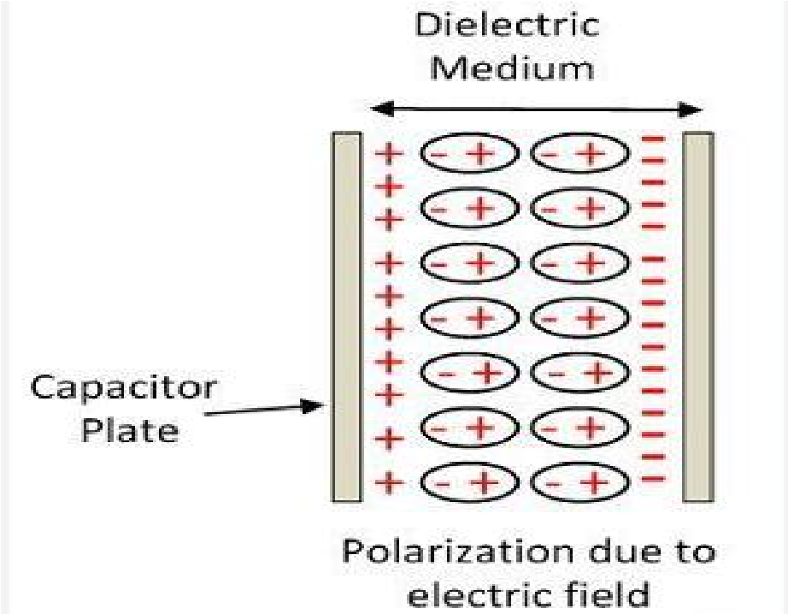
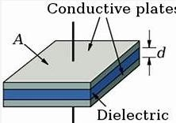
- It is polarized when a voltage is applied across a dielectric surface. Because atoms consist of a positively charged nucleus and negatively charged electrons, polarization is an effect that slightly shifts electrons towards the positive voltage.
- Relative permittivity/dielectric constant is the permittivity of a material expressed as a ratio with the electric permittivity of a vacuum.
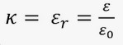
Note: Dielectric Types: Polar Dielectrics (H2O, CO2), Non-Polar Dielectric (H2, N2, O2)
- They do not travel far enough to create a current flow through the material the shift is microscopic, but has a very important effect, especially when dealing with capacitors.
- Dielectric strength: A limit on the voltage an insulator can withstand before conducting electricity. All materials have an upper voltage limit, called breakdown voltage.
- The dielectric strength for air is approximately 3 megavolts per meter. In comparison, the dielectric strength for mica is approximately 120 MV/m.
- After the breakdown field strength is exceeded, air is ionized (electrons are torn away from the atom’s nucleus) and they begin moving under the influence of the electric field, producing electrical current.
- Dielectric Loss: The loss of energy that goes into heating a dielectric material in a varying electric field.
- During the alternation of polarity of the plates, the charges must be displaced through the dielectric first in one direction and then in the other, and overcoming the opposition that they encounter leads to a production of heat through dielectric loss.
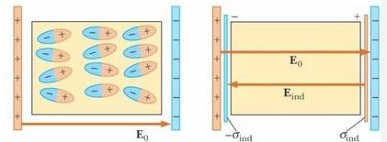
- Internal field: When an external electric field is applied on a conductor, the charges are aligned in such a way that an internal electric field is created which cancels the external electric field.

Piezoelectric materials
- Piezoelectric materials are materials that have the ability to generate internal electrical charge from applied mechanical stress. The term piezo is Greek for "push.“
- Crystal materials like Quartz (SiO₂), Rochelle salt (𝐾𝑁𝑎𝐶₄𝐻₄𝑂₆. 4𝐻₂𝑂), Tourmaline etc. and some organic substances as silk, wood, enamel, bone, hair, rubber, dentin comes under this category.
- The Curie brothers, Pierre and Jacques, first proved the direct piezoelectric effect in 1880.
- Quartz and Rochelle salt demonstrated the highest piezoelectric effects.
➢Tourmaline is a trigonal crystalline complex boron silicate mineral composed of aluminum, iron, magnesium, lithium, and potassium
Direct Piezoelectric Effect: When mechanical stress or friction is applied on these materials the geometry of the atomic structure of the crystal changes due to net movement of positive and negative ions with respect to each other, resulting in electric dipole or Polarization. Thus the crystal changes from a dielectric to a charged material. The amount of voltage generated is directly proportional to the amount of stress or tension applied to the crystal.
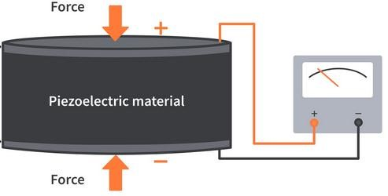
Converse Piezoelectric Effect: It is found in 1881 by Gabriel Lippman, when electricity is applied to these crystals electric dipoles appear, forming the dipole movement which causes deformation of the crystal, thus giving rise to converse piezoelectric effect as shown in the figure.
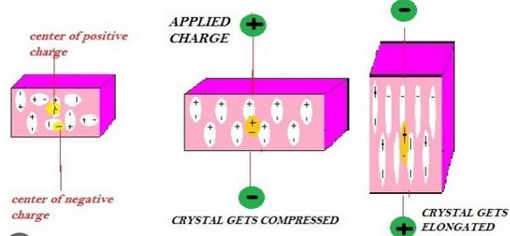

Ultrasonic Waves
- The normal audible sound wave for human being is 20Hz to 20KHz, below 20Hz which are called infrasonic waves and above 20kHz are called ultrasonic waves
- Ultrasonic waves travel faster than the speed of audible sound
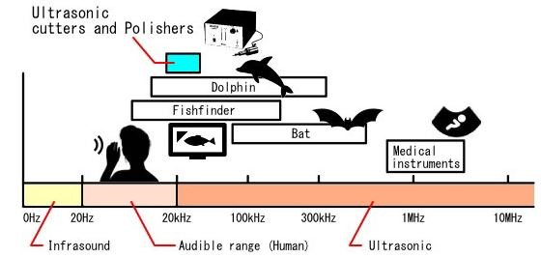

Ultrasonic Sensors
- An ultrasonic sensor is an electronic device that measures the distance of a target object by emitting ultrasonic sound waves, and converts the reflected sound into an electrical signal.
- Ultrasonic sensors have two main components: the transmitter (which emits the sound using piezoelectric crystals) and the receiver (which encounters the sound after it has travelled to and from the target).
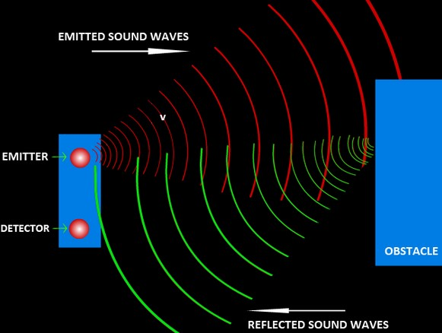

Magnetic Materials
- The origin of magnetism lies in the orbital and spin motions of electrons and how the electrons interact with one another.
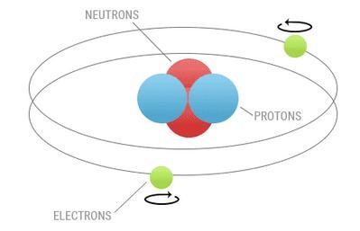
- In its simplest form, the magnetic behaviour of a material is determined by its number of unpaired electrons in each atom. In the atoms of most elements electrons exist in pairs with each electron spinning in a different direction causing them to cancel out each other’s magnetic field, therefore no net magnetic field exists.
- However, some materials have unpaired electrons which will generate a net magnetic field and therefore have a greater reaction to an external magnetic field. Most materials are classified either as ferromagnetic, diamagnetic or paramagnetic.
Magnetization is the density of magnetic dipole moments that are induced in a magnetic material when it is placed near a magnet.

Diamagnetic Materials
- Diamagnetic materials repel any externally applied magnetic field. This occurs because their magnetic domains realign to oppose an externally applied magnetic field when influenced by a magnetic field.
- when placed in a magnetic field. Magnetic dipoles in these substances tend to align in opposition to the applied field. In effect, they produce an internal magnetic field that opposes the applied field and the substance tends to repel the external field around it.
- This opposing field disappears as soon as the external field is removed.
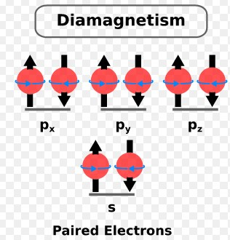
➢Examples: water, wood, gold, Copper, Zinc, Silver, Gold, Antimony, Marble, Glass

Paramagnetic Materials
- Paramagnetic materials are materials that tend to get weakly magnetized in the direction of the magnetizing field when placed in a magnetic field.
- Paramagnetic materials have a permanent dipole moment or permanent magnetic moment.
- The magnetic dipoles in the magnetic materials tend to align along the applied magnetic field and thus reinforcing the applied magnetic field.
- It must be noted that such materials are still feeble magnetised and the magnetisation disappears as soon as the external field is removed.
- Liquid oxygen, sodium, platinum, salts of iron and nickel.
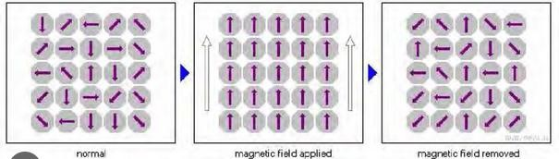

Ferromagnetic Materials
- The ferromagnetic materials are those substances which exhibit strong magnetism in the same direction of the field, when a magnetic field is applied to it. Examples: Iron, Cobalt, Nickel, gadolinium.
- Domains: It is actually a tiny area in ferromagnetic materials with a specific overall spin orientation
- when we consider some unpaired electrons, they will interact with each other between two atoms and they line up themselves in a tiny region 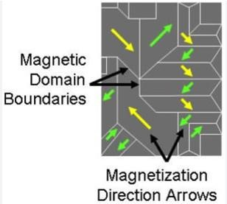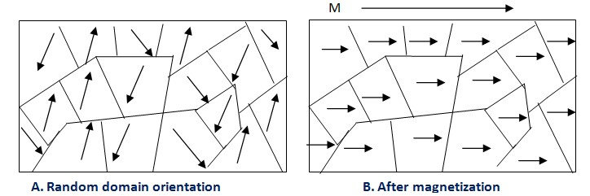with the direction of magnetic field
- Therefore, in a ferromagnetic material in the unmagnetized state, atomic dipoles in small regions called domains are aligned in the same direction. The domains exhibit a net magnetic moment even in the absence of an external magnetizing field.
- Hysteresis: On removing the external magnetic field, a ferromagnetic material doesn’t get demagnetized fully. To bring the material back to zero magnetization, a magnetic field in the opposite direction has to be applied. The property of ferromagnetic materials retaining magnetization after the external field is removed is called hysteresis.
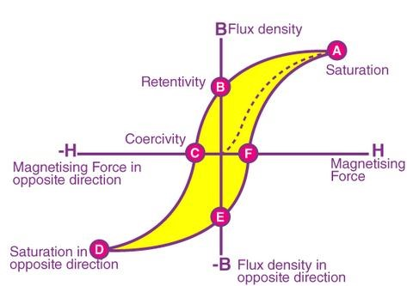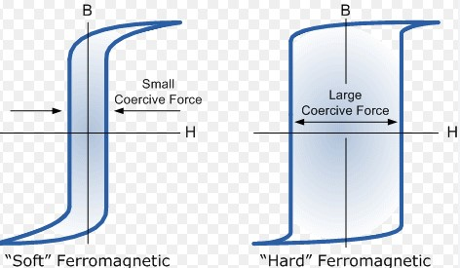
Hysteresis loop
- The shape and the size of the hysteresis loop depend on the nature of the material chosen
- Thus the way to choose perfect material to make permanent magnet, core of machines becomes easier.

Superconducting Materials
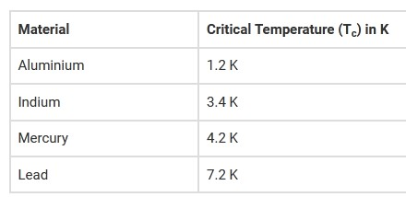
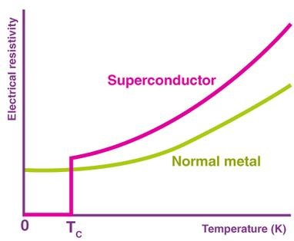
- Superconductors and superconducting materials are metals, ceramics, organic materials, or heavily doped semiconductors that conduct electricity without resistance. ➢ The superconductivity phenomenon was discovered in 1911 by Dutch physicist Heike
Kamerlingh Onnes.
- The superconductor’s resistance drops to zero below a fixed temperature, which is the critical temperature (T_{c}).
Note: Based on BCS theory or Bardeen–Cooper–Schrieffer theory

Meissner Effect
- When a material makes the transition from the normal to superconducting state, it actively excludes magnetic fields from its interior; this is called the Meissner effect.
- superconducting materials set up electric currents near their surface at T_{c}, therefore canceling the fields within the material itself.
- Properties of superconductors
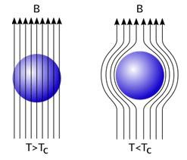
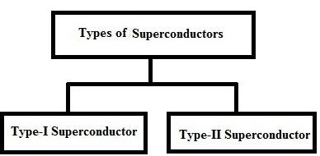
- Zero Electric Resistance (Infinite Conductivity),
- Expulsion of magnetic field
- Critical Temperature/Transition Temperature
- Critical Magnetic Field
➢Superconductors are of two types
Type-I Superconductor: are those superconductors that lose their superconductivity very easily or abruptly when placed in the external magnetic field. Examples: Lead, Tin, Mercury
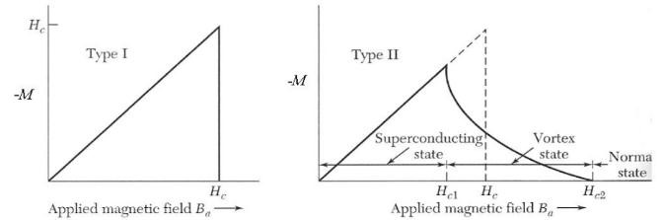
A type II superconductor: will only keep the whole magnetic field out until a first critical field Hc1 is reached. Then vortices start to appear. A vortex is a magnetic flux quantum that penetrates the superconductor. Where the vortex appears the superconducting order parameter drops to zero. In this region the metal is no longer a superconductor. Eg: Alloy like Nb-
Sn, Nb-Ti etc

BCS (Bardeen–Cooper–Schrieffer) Theory
- Bardeen–Cooper–Schrieffer theory (named after John Bardeen, Leon Cooper, and John Robert Schrieffer)
- Cooper had discovered that electrons in a SC are grouped in pairs, now called Cooper pairs.
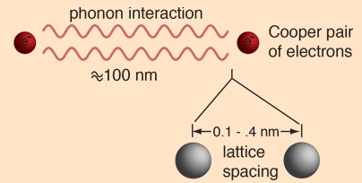
- The motions of all of the Cooper pairs within a single superconductor are correlated; they constitute a system that functions as a single entity.
➢Application of an electrical voltage to the superconductor causes all Cooper pairs to move, constituting a current.

BCS Theory
➢When the voltage is removed, current continues to flow indefinitely because the pairs encounter no opposition. For the current to stop, all of the Cooper pairs would have to be halted at the same time, a very unlikely occurrence. As a superconductor is warmed, its Cooper pairs separate into individual electrons, and the material becomes normal, or nonsuperconducting.
➢Conclusion: Meissner Effect talks about the expulsion of the magnetic field, which helps convert material from normal state to superconducting state, which is when cooled below the critical temperature or transition temperature. The major importance of the Meissner Effect is in the field of superconductivity and magnetic levitation.

Magnetic Data Storage
- Magnetic storage devices always use the magnetization process to write, rewrite, and get access data.

- Magnetic storage is also known as “Magnetic Media” or “Magnetic Memory” or “Magnetic Medium“. In the Magnetic storage devices, all data are stored with using magnetized medium, and those types of data saved in that medium in the binary form like as 0 and 1.
- The magnetic storage device contains iron oxide or ferrite elements surrounded by a thin film of plastic.

Applications of Superconductor Materials
- Generation and transmission of electric power
- Medical diagnosis
- Electromagnets (superconducting magnets)
- In the making of Supercomputers
- Magnetically levitating the world’s fastest trains
- Magnetic Energy storage Devices
- Electromagnetic shielding
- In the medical industry as superconducting quantum Interferometers (SQUIDS).

Nanomaterials
- Materials of which a single unit is sized (in at least one dimension) between 1 and 100 nm.
- They may be in the form of particles, tubes, rods or fibres.
- Some nanomaterials can occur naturally such as a) blood borne proteins essential for life b) lipids found in the blood and body fat c) Our bones are also composed of nano structured minerals d) cosmic and moon dust
- Nanotechnology: The American physicist and Nobel Prize laureate Richard Feynman introduce the concept of nanotechnology in 1959.

Classification of Nanomaterials
- Zero Dimension: These materials don’t have any dimensions. Point materials including oxides, semiconductors, quantum dots, hollow spheres. 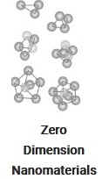 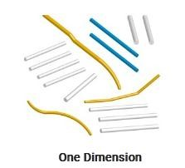
- One Dimension: The one billionth of any given unit that is a film of thin type is known as one dimension nanoparticles. It is used in engineering, electronics, chemistry, and so on for many decades. These are used in the construction of nanorods, nanowires, nanotubes.
- Two Dimension: This structure consists of two dimensions that are outside the range of nanometric size. It has characteristics dependent upon the shapes. Monolayer, Multilayer, Self- assembled.
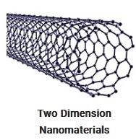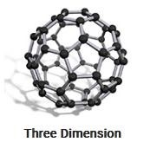
- Three Dimension In this, the structure consists of three dimensions. These are most widely used in magnetic materials, catalysts. These 3-D structures are further categorized as Fullerenes and Quantum Dots.

Synthesis of Nanomaterial
- Nanostructure materials have attracted a great deal of attention because their physical, chemical, electronic and magnetic properties show dramatic change from higher dimensional counterparts and depends on their shape and size.
- Many techniques have been developed to synthesize and fabricate nanostructure materials with controlled shape, size, dimensionality and structure.
- Classification of Techniques for synthesis of Nanomaterials
  - Top- down approach
  - Bottom–up approach.
- Bottom-up approach refers to the build up of a material from the bottom: atom-by-atom, molecule-by-molecule,
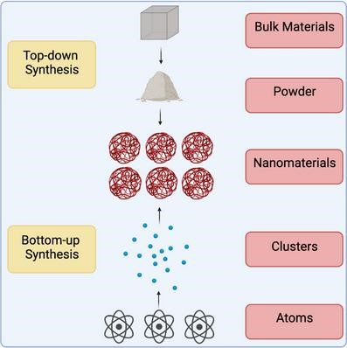
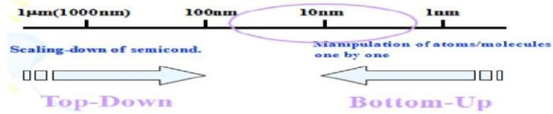
- It is a building of even more complex molecular devices on an atomic arrangement.
➢
Based
on
Bottom
-
up
approach
:
synthesis,
colloidal
precipitation,
hydrothermal
synthesis,
template
assisted
sol
-
gel,
electro
-
deposition
etc
,
sol-gel
- Top-down approach deals with the reduction in size of current technological devices
- Top-down synthesis techniques are extension of those that have been used for producing micron sized particles.
- Based on Top-down approach: high-energy wet ball milling, electron beam lithography, atomic force manipulation, gasphase condensation, aerosol spray, etc.
- The biggest problem with top-down approach (physical methods) is the imperfection of the surface structure.
Among the top-down and bottom-up approaches, the bottom-up approach is more accepted in synthesis of nanoparticles due to many merits as fewer defects, more homogenous chemical composition and better ordering.

Thank you……

